1)

Code:

DROP TABLE IF EXISTS w5q1_co;

CREATE DATABASE w5q1_co;

USE w5q1_co;

CREATE TABLE Employee (

Emp_No INT,

Emp_Name VARCHAR(30),

sex VARCHAR(10),

Salary INT,

Address VARCHAR(100),

Dept_No INT

);

INSERT INTO Employee VALUES

(26, 'Simon L Messerly', 'male', 41000, '4971, Hillcrest Lane, Moreno Valley, California', 291),

(29, 'Leroy A Preston', 'male', 104000, '1034 Lyon Avenue, Framingham, Massachusetts', 170),

(56, 'Juanita J Tomlin', 'female', 53000, '2101 Hedge Street, Branchburg, New Jersey', 817),

(60, 'William J Welton', 'male', 26000, '1475 Sundown Lane, Austin, Texas', 752),

(25, 'Dianne P Saulsbury', 'female', 53000, '4089 Bernardo Street, Polk City, Florida', 868),

(34, 'Amy I Taylor', 'female', 57000, '2946 Meadowbrook Mall Road, Playa Del Rey, California', 291),

(40, 'Keith J Williams', 'male', 41000, '936 Clousson Road, HACKENSACK, New Jersey', 817),

(22, 'Homer K Linger', 'male', 77000, '4626 Larry Street, NOVELTY, Missouri', 623),

(66, 'Helga J Beck', 'female', 71000, '3904 Metz Lane, Cambridge, Massachusetts', 170),

(36, 'William S Burnett', 'male', 50000, '3409 Emily Renzelli Boulevard, Salinas, California', 291);

CREATE TABLE Department (

Dept_No INT,

Dept_Name VARCHAR(20),

Location VARCHAR(20)

);

INSERT INTO Department VALUES

(170, 'Technology', 'Massachusetts'),

(291, 'Entertainment', 'California'),

(752, 'Agriculture', 'Texas'),

(817, 'Sales', 'New Jersey'),

(623, 'Medical', 'Missouri'),

(868, 'Tourism', 'Florida');

-- DROP DATABASE w5q1_co;

Input:

* Employee Table

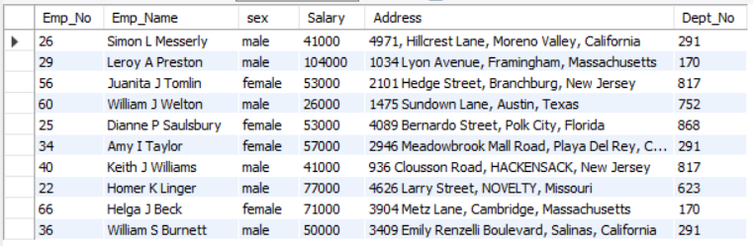

* Department Table

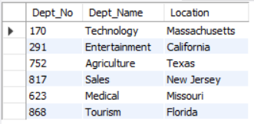

Queries & Outputs:

-- 1a) Write a procedure to display employee details given the Emp_No.

-- CREATE PROCEDURE disp_emp(IN eno INT)

-- SELECT * FROM Employee

-- WHERE Emp_no = eno;

-- CALL disp_emp(60);

DELIMITER //

DROP PROCEDURE IF EXISTS show_emp//

CREATE PROCEDURE show_emp (IN eno INT)

BEGIN

SELECT * FROM Employee WHERE Emp_No = eno;

END//

DELIMITER ;

CALL show_emp(60);



-- 1b) Write a procedure to delete an employee record given the Emp_Name.

DELIMITER //

DROP PROCEDURE IF EXISTS del_emp//

CREATE PROCEDURE del_emp(IN ename VARCHAR(30))

BEGIN

DELETE FROM Employee

WHERE Emp_name = ename;

END//

DELIMITER ;

CALL del_emp('William S Burnett');

SELECT * FROM Employee;

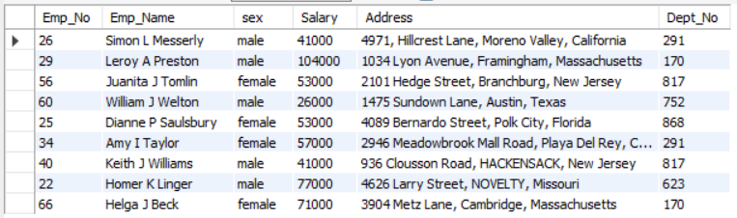

-- 1c) Write a procedure to list all the employee names belonging to a particular department given

-- the Dept_No.

DELIMITER //

DROP PROCEDURE IF EXISTS disp_emp_dept//

CREATE PROCEDURE disp_emp_dept(IN dept INT)

BEGIN

SELECT * FROM Employee

WHERE Dept_No = dept;

END//

DELIMITER ;

CALL disp_emp_dept(170);

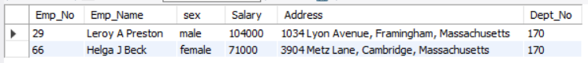

-- 1d) Write a procedure to display the number of employees whose salary is greater than 30K.

DELIMITER //

DROP PROCEDURE IF EXISTS sal_30k//

CREATE PROCEDURE sal_30k(OUT numEmp INT)

BEGIN

SELECT COUNT(Emp_No) INTO numEmp FROM Employee

WHERE Salary > 30E3;

END//

DELIMITER ;

CALL sal_30k(@N);

SELECT @N as Num_Of_Employees;



2)

Code:

DROP DATABASE IF EXISTS w5q2_sasalele;

CREATE DATABASE w5q2_sasalele;

USE w5q2_sasalele;

CREATE TABLE Customer(

customer_id int,

cust_name varchar(50),

city varchar(25),

grade int,

salesman_id int

);

INSERT INTO Customer(customer_id, cust_name, city, grade, salesman_id) VALUES

(3002, 'Nick Rimando', 'New York', 100, 5001),

(3007, 'Brad Davis', 'New York', 200, 5001),

(3005, 'Graham Zusi', 'California', 200, 5002),

(3008, 'Julian Green', 'London', 300, 5002),

(3004, 'Fabian Johnson', 'Paris', 300, 5006),

(3009, 'Geoff Cameron', 'Berlin', 100, 5003),

(3003, 'Jozy Altidor', 'Moscow', 200, 5007),

(3001, 'Brad Guzan', 'London', 300, 5005);

CREATE TABLE Orders(

ord_no int,

purch_amt double,

ord_date date,

salesman_id int,

customer_id int

);

INSERT INTO Orders(ord_no,purch_amt,ord_date,customer_id,salesman_id) VALUES

(70001, 150.5, '2012-10-05', 3005, 5002),

(70009, 270.65, '2012-09-10', 3001, 5005),

(70002, 65.26, '2012-10-05', 3002, 5001),

(70004, 110.5, '2012-08-17', 3009, 5003),

(70007, 948.5, '2012-09-10', 3005, 5002),

(70005, 2400.6, '2012-07-27', 3007, 5001),

(70008, 5760, '2012-09-10', 3002, 5001),

(70010, 1983.43, '2012-10-10', 3004, 5006),

(70003, 2480.4, '2012-10-10', 3009, 5003),

(70012, 250.45, '2012-06-27', 3008, 5002),

(70011, 75.29, '2012-08-17', 3003, 5007),

(70013, 3045.6, '2012-04-25', 3002, 5001);

-- DROP DATABASE w5q2_sasalele;

Table:

* Customer Table

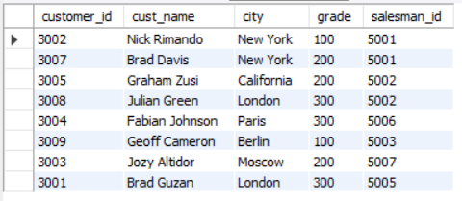

* Orders Table

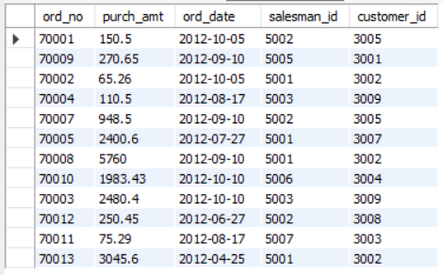

Queries & Outputs:

-- 2a) Use SQL functions to find the highest purchaseamount ordered by each customer with theirID and highest purchase amount.

DELIMITER //

CREATE FUNCTION max_purch_amt(c_id int)

RETURNS DECIMAL(10,2) DETERMINISTIC

BEGIN

DECLARE max_amt DECIMAL(10,2);

SELECT MAX(purch_amt) INTO max_amt FROM Orders WHERE customer_id = c_id;

RETURN max_amt;

END //

DELIMITER ;

SELECT customer_id, max_purch_amt(customer_id) FROM Orders GROUP BY customer_id;

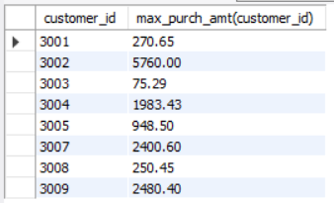

-- 2b) Use SQL functions to find the number of customers in each city

DELIMITER //

DROP FUNCTION IF EXISTS cust_per_city//

CREATE FUNCTION cust_per_city(city_name VARCHAR(20))

RETURNS INT DETERMINISTIC

BEGIN

DECLARE CNT INT;

-- SET CNT = 0;

SELECT COUNT(*) INTO CNT FROM Customer WHERE city = city_name;

RETURN CNT;

END //

DELIMITER ;

SELECT city, cust_per_city(city) FROM Customer GROUP BY city;

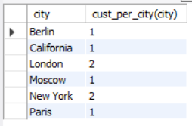

-- 2c) Write a user defined function to display customer details given the customer_id.

DELIMITER //

DROP PROCEDURE IF EXISTS disp_cust_info //

CREATE PROCEDURE disp_cust_info(IN customer_id_in INT)

BEGIN

SELECT * FROM Customer WHERE customer_id = customer_id_in;

END //

DELIMITER ;

CALL disp_cust_info(3002);



-- 2d) Write a user defined function to decrease the purch_amt of an order by 5% given the ord_no.

DELIMITER //

DROP FUNCTION IF EXISTS dec_purch_amt //

CREATE FUNCTION dec_purch_amt(orderno INT)

RETURNS DOUBLE DETERMINISTIC

BEGIN

DECLARE purch_amt_new DOUBLE;

SELECT purch_amt INTO purch_amt_new FROM Orders WHERE ord_no = orderno;

RETURN (purch_amt_new * 0.95);

END //

DELIMITER ;

UPDATE Orders SET purch_amt = dec_purch_amt(ord_no) WHERE ord_no = 70001;

SELECT * FROM Orders;

